Team Worksheet 3 – CS545
Name of Project:
LearningX

List of Team Members:
Jianhong Mou
Neil Hinrichs
Patrick Hill
Sarah Inman
Tianyo Luo

Describe the electronic workspace for your project and explain how you are using it. Do you use google docs, dropbox, git, …? What prototyping tools and languages are you using and how are you using them?

We use google docs as our collaborative space. This has been our medium for sharing documents and working on the project asynchronously. We also use Skype and https://appear.in/experience for synchronous group meetings. We’ve used Doodle to find the best times for us to meet. We used Balsamiq to develop the low-fidelity prototype. We are now using Pencil for developing medium to high fidelity prototypes.
We use github as the control system. We use HTML, CSS and Javascript to the front-end works, such as display information and iterative with users. In the back-end, we use Java to do logical things. Meanwhile, we choose SQL to communicate with our database.

Attach any questionnaire or survey you may have administered and also the analysis of the data, including how many persons participated.

We administered a survey to students in two Stevens’ Intro Java Programming courses. All results have yet to come in, but so far – this is what we have collected:

31 total respondents

When asked about what attributes they found most engaging in a website, an overwhelming majority (60%) responded with social sharing. 48.4% selected viewing videos and 42% said simplistic interface. When asked how they learn most effectively, a majority (67.7%) selected hands on, project-based assignments. Other popular methods were watching videos (64.5%), using the Internet for research (54.8%), and discussing with peers (51.6%). The lowest effective methods were somewhat surprising: playing a game (12.9%), listening to podcasts (16.1%), and writing (35.5%).
Users were also asked to rate the interface for one of our low-fidelity prototypes. The majority gave it an average rating, and provided some feedback for us to incorporate in our design.
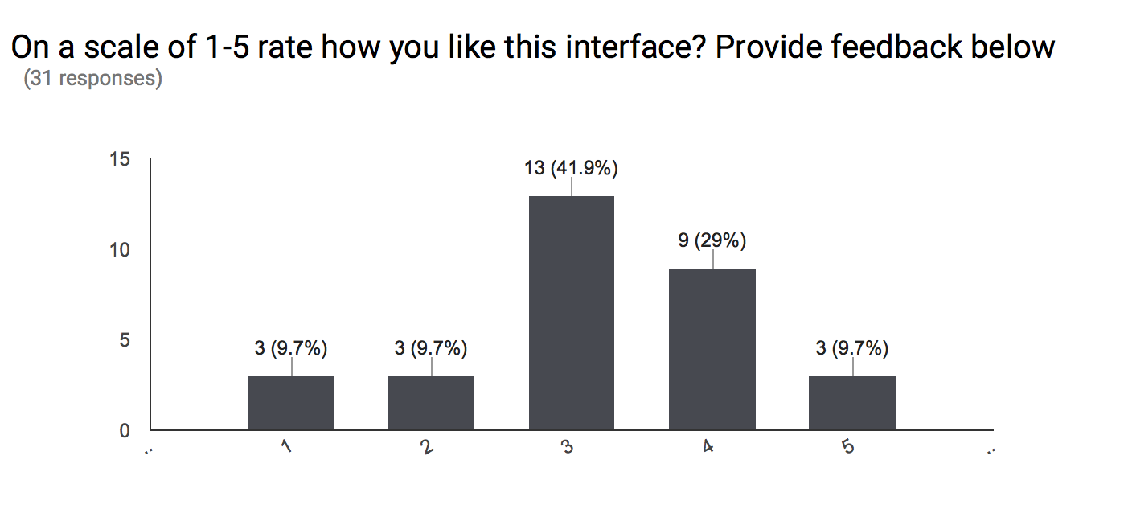
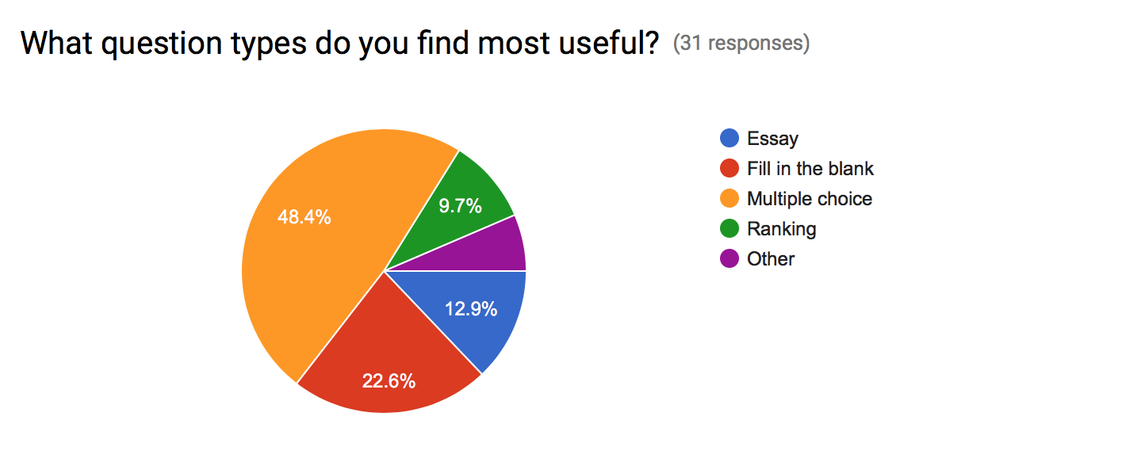
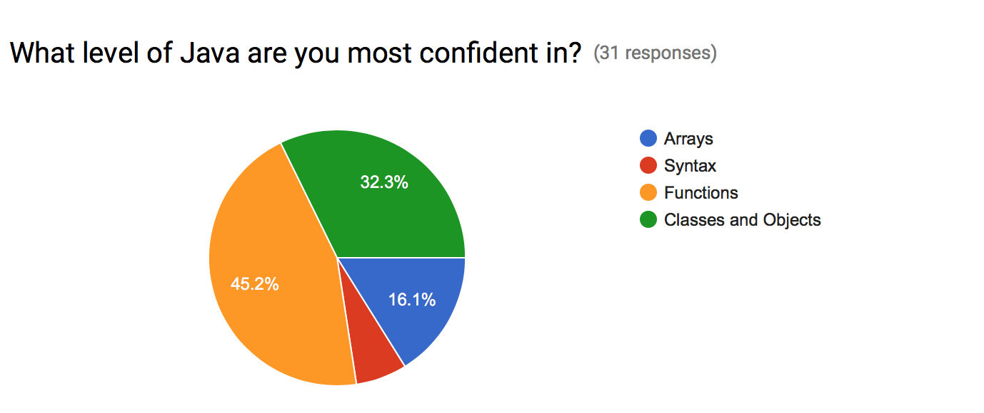
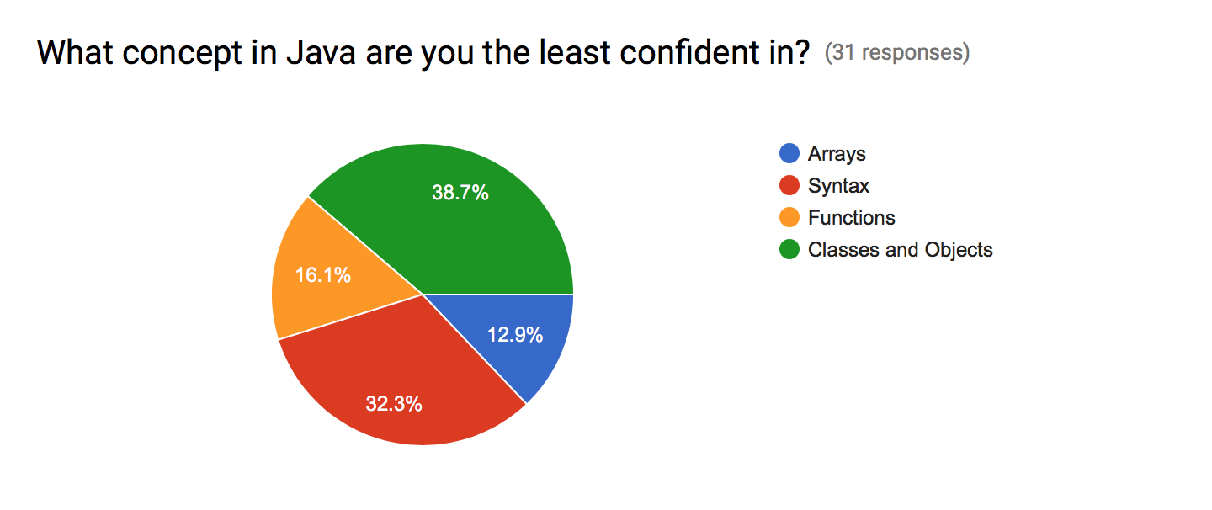
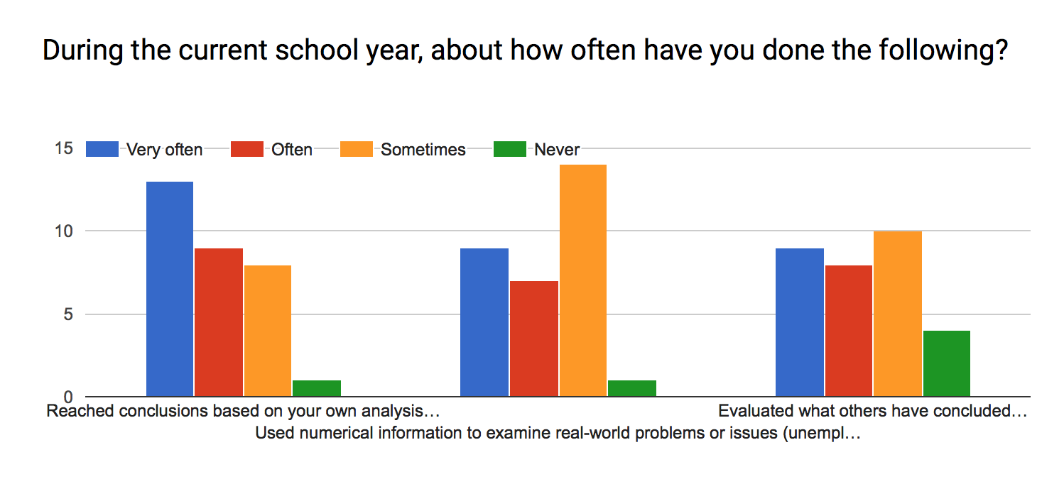

The National Survey of Student Engagement’s Engagement Indicators produces a report on engagement indicators; in this report they list four important themes: academic challenge (higher order learning and reflection), learning with peers, experiences with faculty, and campus environment. We chose to look at findings for first-year students as opposed to seniors as our target user will be in their first few years of university. Key findings for increasing engagement:
Connecting your ideas from your courses to your prior experiences and knowledge
Working with students on course projects and assignments
Discussion with diverse “others”

A potential pain point is that the system is completely online. Therefore, it is hard to design for campus environment and collaboration. Throughout our own collaborative work, we have learned that a structure is needed to keep online participants engaged.

Provide a description of your low fidelity prototyping technique and attach any paper prototypes.

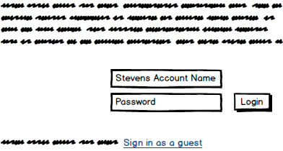

This is our login page to have people access their own account. The user's account will hold onto the users progress in their questions / learning modules. Alternatively they can sign in as a guest and not have information saved.
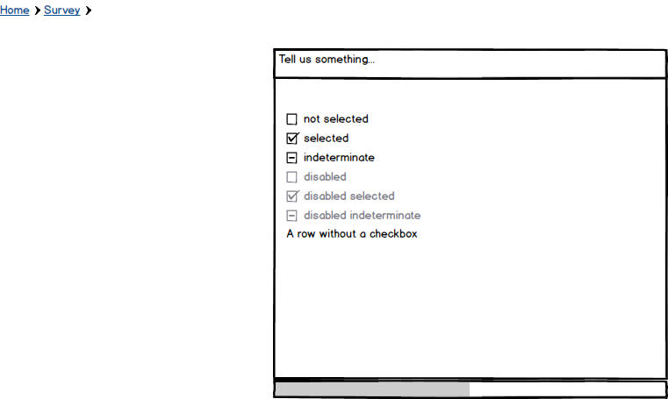
If the user selects student, they will be given a pop up screen. This prompt will ask a few questions to gauge where the user is in their learning process. There is also a progress bar at the bottom of the survey. This is where we want to learn more about our user's goals for learning java.

Alternatively, we could start with a video.
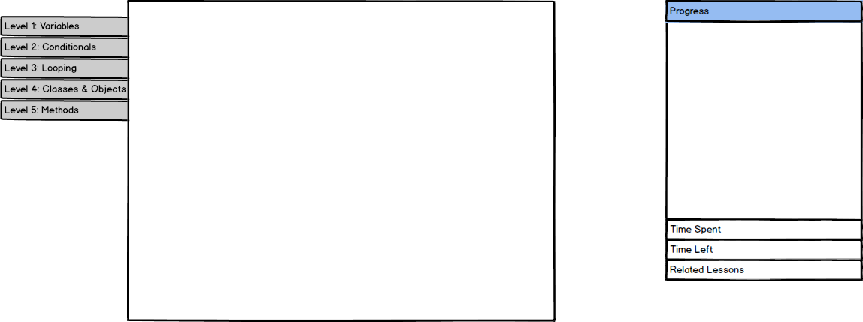
Here is the traditional user view. In the center box will be our main content. As of right now questions will exist there and will transition to suggested lessons and potentially games to play about the topics.
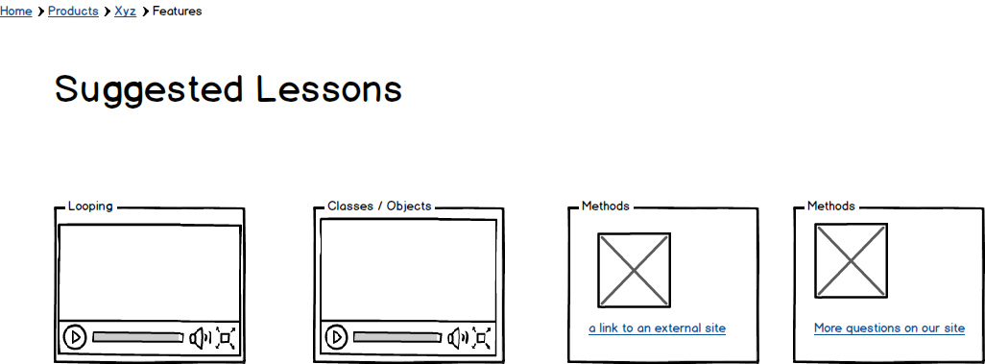
Here is the Explore user experience. After finishing the content a user will be directed here. This is where they can get access to other sources of knowledge. These four are the options of additional content.
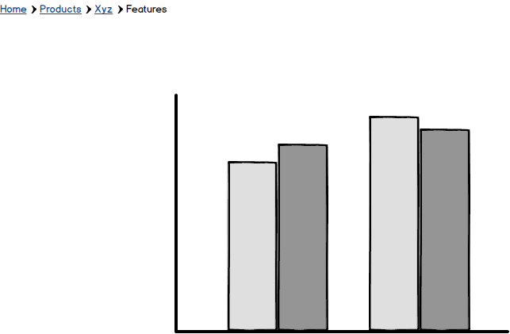
In this section, students will be able to reflect on his or her progress.

Provide a description of your medium fidelity prototype. Provide any data you may have collected.

Learning X - Prototype
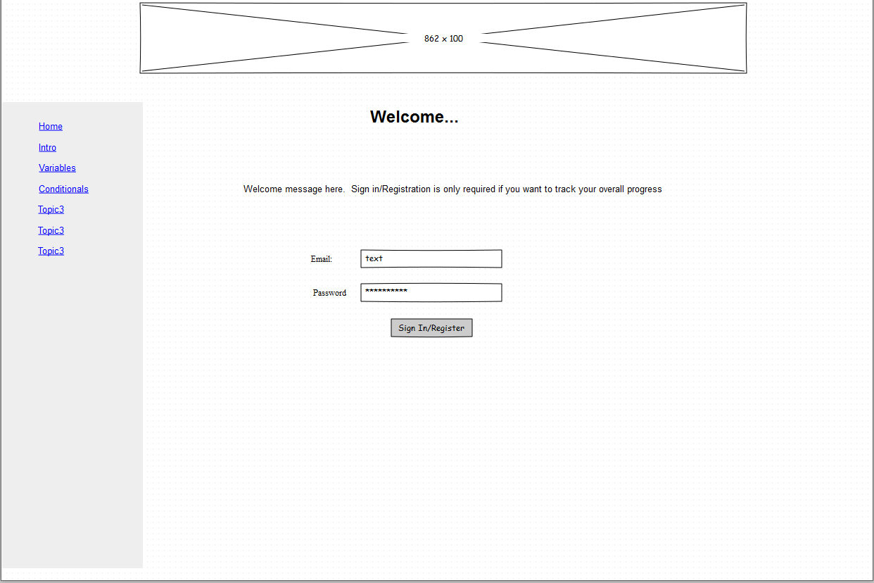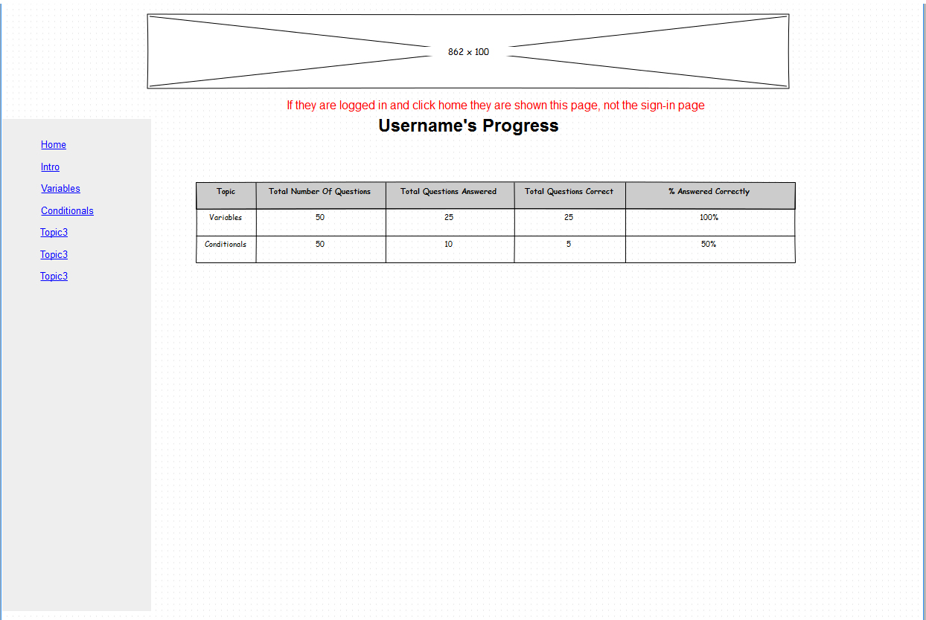
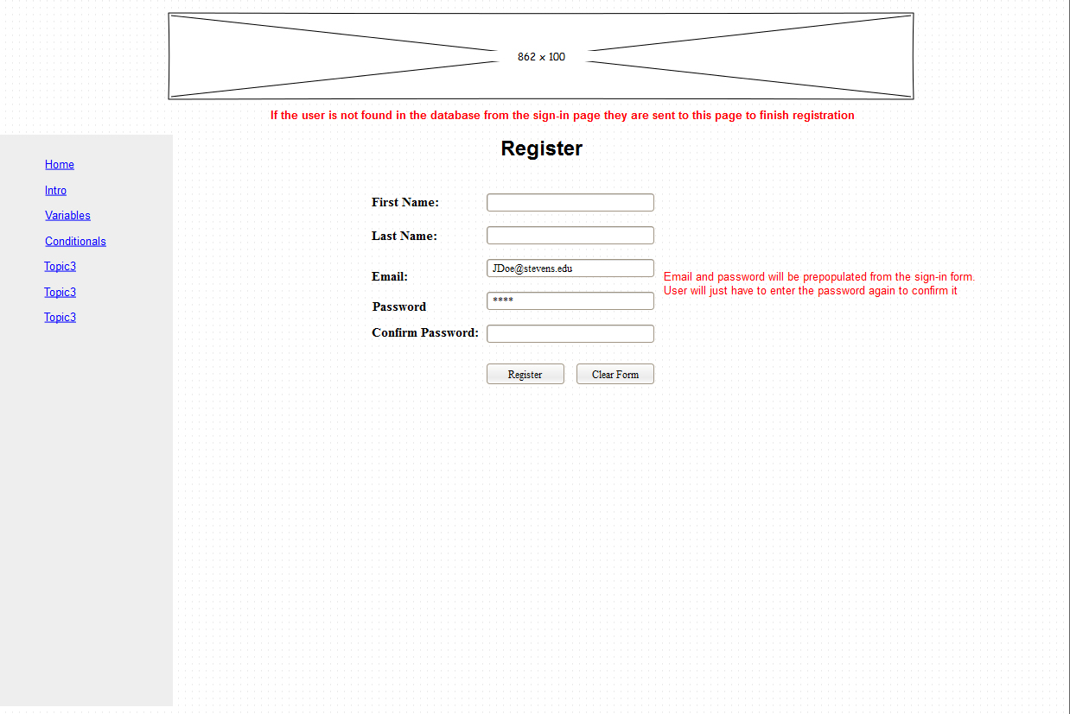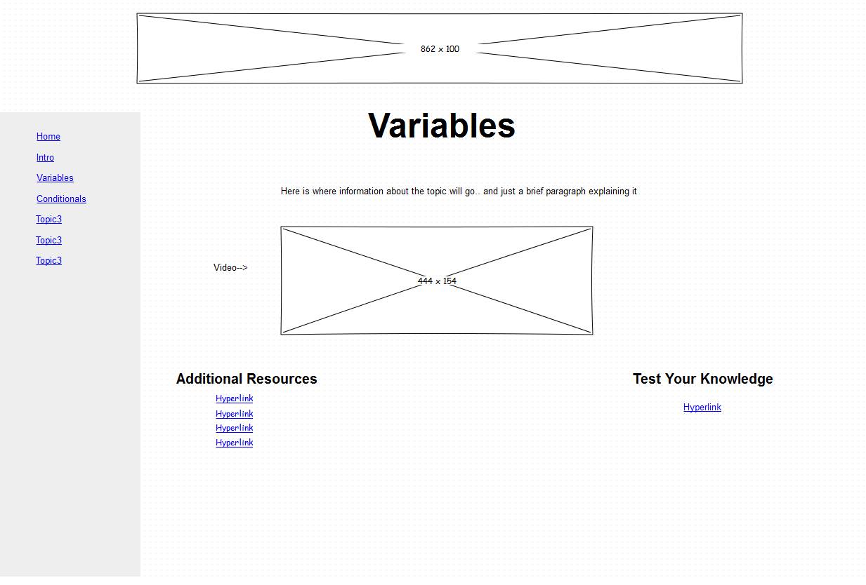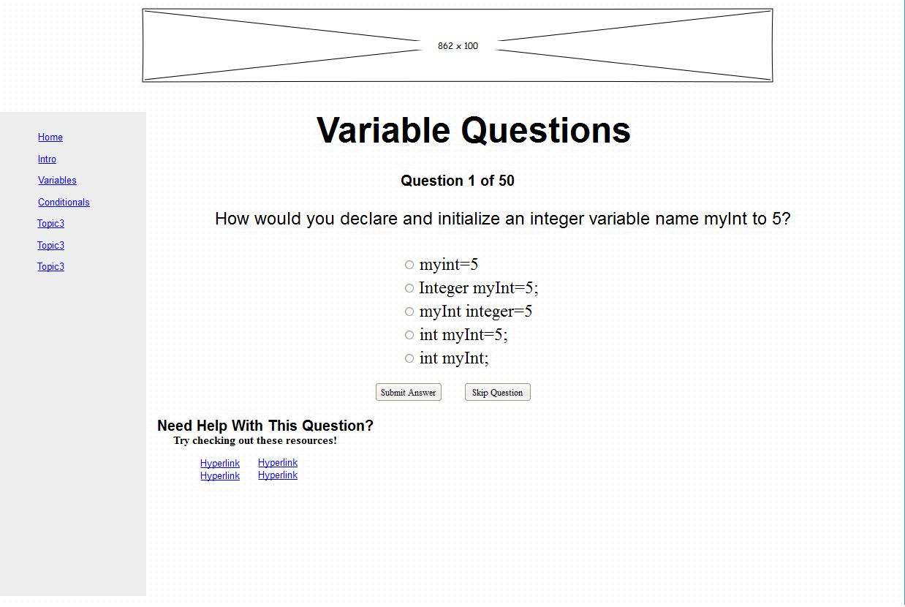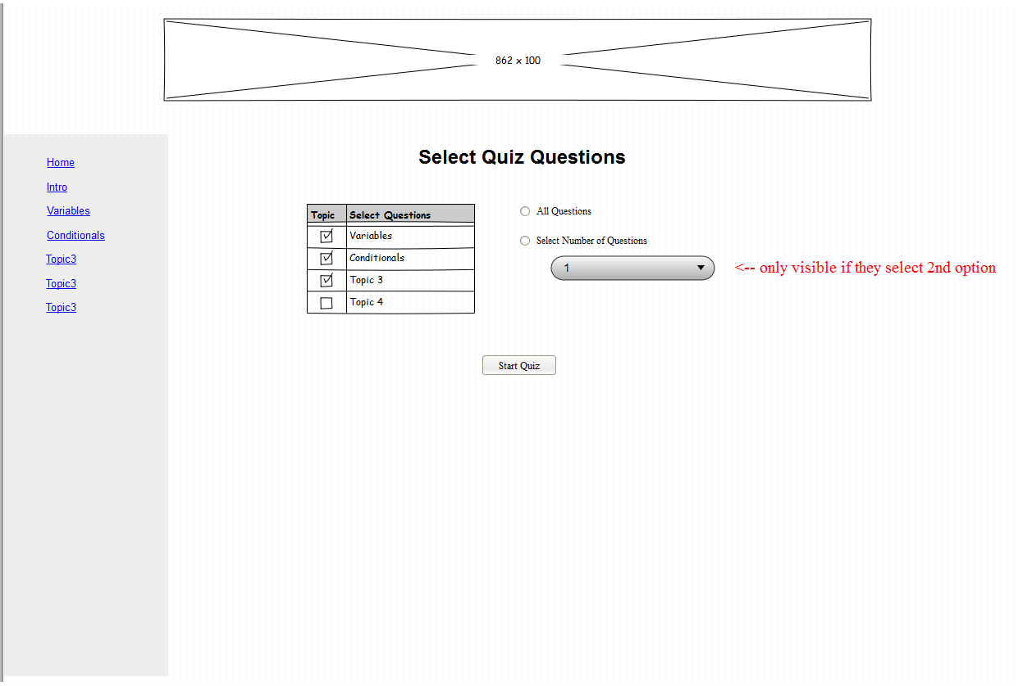

http://xfactor.abstractlogic.nyc/register
http://xfactor.abstractlogic.nyc/login
http://xfactor.abstractlogic.nyc/forgotpassword
http://xfactor.abstractlogic.nyc/changepassword

At the beginning, when the user registers, we can ask them to finish a small piece of code to introduce themselves. Like,
public class MySelf{
private String firstName;
private String lastName;
private int age;
public MySelf(String firstName, String lastName, int age){
this.firstName = firstName;
this.lastName = lastName;
this.age = age;
}
}
Or just,
public void intro(){
System.out.println(“Hello all.”)
}
This is the initial code piece. In every section, we ask users to finish code piece like that and these should be identical.
When the user failed login, we can provide some pieces of code to them and get them to recognize code from themselves. This is similar to security questions, but users don’t need to remember the specific words they wrote before.

